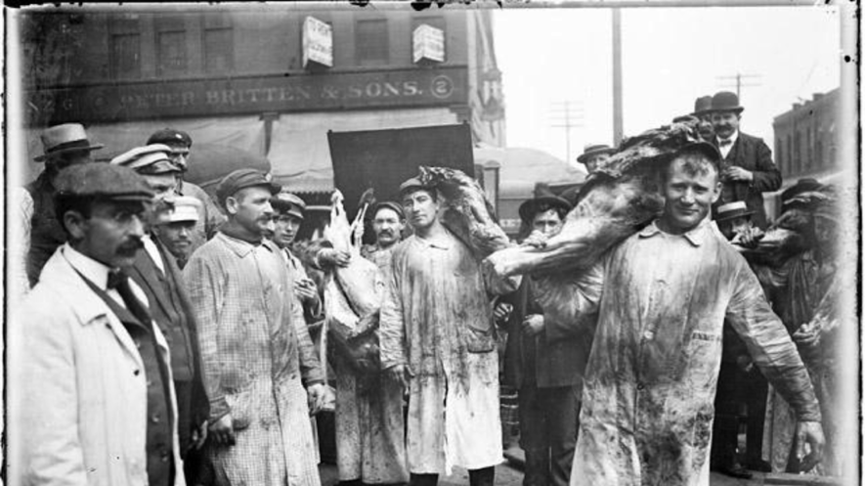
Men wearing bloody butcher coats and carrying animal carcasses gather in a street in front of Peter Britten and Sons while other men look on during the 1904 Stockyards Strike in Chicago, Illinois, August 8, 1904. From the Chicago Daily News.
Upton Sinclair’s "The Jungle" Leads to Meat Inspection Laws
On June 30, 1906, President Theodore Roosevelt signed into law the Meat Inspection Act, reforming the meatpacking industry. The act prohibited the sale of contaminated or mislabeled food products that came from animals. It also made sure that livestock such as cattle, swine, sheep, goats and horses were killed and processed under sanitary conditions. The U.S. Department of Agriculture (USDA) was now required to inspect all livestock both before and after slaughter and processing. The law also applied strict inspection standards on imported meat products. Previous laws that had allowed the USDA to conduct such inspections had proven ineffective. For example, the Meat Inspection Acts of 1890 and 1891 had done little to change many unsafe and unsanitary practices by the meatpacking industry. Later laws such as the Wholesome Meat Act of 1967 continued to address this issue.
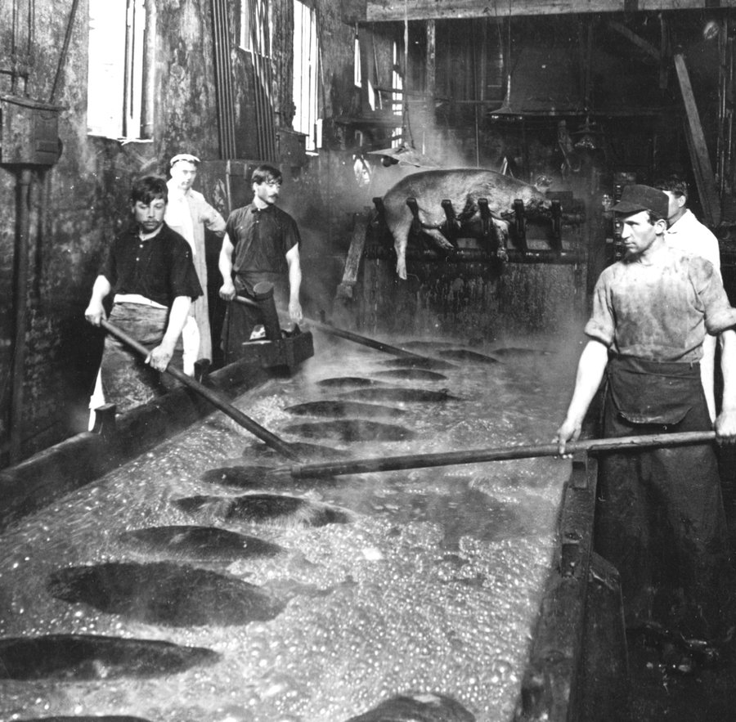
Unsafe practices draw attention Beginning in the 1880s government reports noted the health risks of contaminated foods. Processed foods such as canned meat contained impurities and chemicals to preserve or color them. American chemist Harvey W. Wiley, chief of the Bureau of Chemistry of the USDA, was an early proponent of change. He authored and sent reports to industry organizations such as the Association of Official Agricultural Chemists. He also began lobbying for federal legislation to govern the packing and purity of food products. The first widespread public attention to these unsafe practices came in 1898, when the press reported that Armour & Company, a Chicago meat packer, had supplied tons of rotten canned beef to the U.S. Army in Cuba during the Spanish-American War. The meat had been packed with a visible layer of boric acid, which was thought to preserve meat, and was used to mask the smell of the rotted product. Troops who ate the meat fell ill and were unfit for combat. Some died. Roosevelt, who served in Cuba as a colonel, testified in 1899 that he would have eaten his old hat as soon as eat what he called “embalmed beef.”
"Beef Trust" at center of outrage The canned-meat scandal prompted a former superintendent for Armour & Company named Thomas F. Dolan to provide a sworn statement that government inspectors were ineffective and the company's practices were disgraceful. In fact, Dolan said the company’s common practice was to pack and sell decaying meat, or “carrion.” The New York Journal newspaper published Dolan’s statement on March 4, 1899. As a result, the Senate formed the Pure-Food Investigating Committee. From 1899 to 1900, the committee held hearings in Chicago, Washington, D.C., and New York City. It determined that chemicals commonly added to preserve meats, such as borax, salicylic acid and formaldehyde, were “unwholesome.” The press attended the hearings and reported that foreign or inferior substances were added to some foods, making them impure. These concerns were in addition to the health problems posed by the packaging of substandard or condemned meat products. Public outrage centered on a group of meat packers known as the “Beef Trust.” It consisted of the five largest meatpacking companies and its base of packinghouses in Chicago. The Beef Trust was representative of the rising power of business and industry in the 19th century. During the following Progressive Era, journalists responded by reporting on corruption by those in power — journalists who wrote such pieces were called "muckrakers." Muckrakers detailed the unjust working conditions and unsanitary workplaces of the Beef Trust. They also exposed their methods to evade any government inspection. Of those journalists, American writer Charles Edward Russell is perhaps best known. He wrote a series of articles about the Beef Trust that were published as "The Greatest Trust in the World" (1905). Picture above: Boiling vats used to prepare hogs for hair removal in Chicago around 1890.
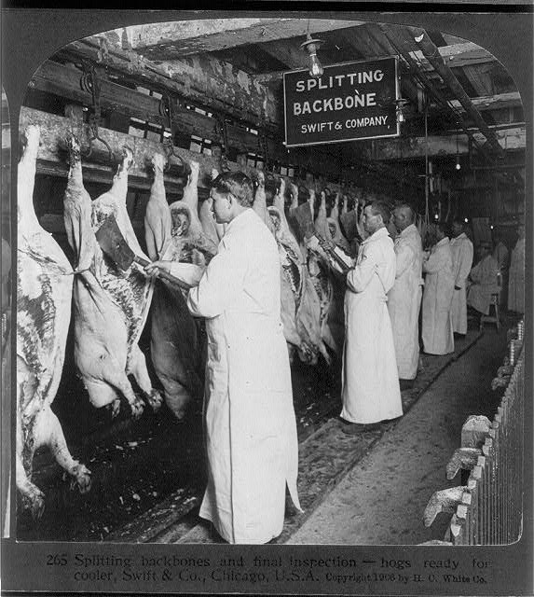
Public response follows "The Jungle" The work of Upton Sinclair created broad public support for change. In 1904, Sinclair covered a labor strike at Chicago’s Union Stockyards for the magazine Appeal to Reason. The magazine was a voice of socialism — the idea that the community, not business, should regulate or own resources. Appeal to Reason commissioned Sinclair to spend a year in Chicago to research and write about the Beef Trust’s treatment of workers. "The Jungle," published in 1906, was Sinclair's best-known novel. It vividly described the horrific working conditions and food-preparation practices at meatpacking plants. Appeal to Reason published Sinclair's articles in several installments beginning on February 25, 1905. Doubleday, Page & Company published the complete novel a year later. Roosevelt was sent an advance copy of "The Jungle." The president was known as a "trustbuster" who believed in limiting the power of large and corrupt institutions. He sent Labor Commissioner Charles P. Neill and social worker James Bronson Reynolds to investigate the Beef Trust. They confirmed Sinclair's portrayal of the conditions at the packinghouses. Sinclair's novel was an instant international best-seller and prompted massive public outrage about food contamination and sanitation. Sinclair’s primary intent, however, had been to promote socialism. Other muckrakers and Progressive activist also called for reform in government regulation of industry, contributing significantly to the broad public response. There also was growing support for regulation among those in the industry because of the heightened public awareness. Legislation to address food safety had been proposed in 1905, but by 1906 it had stalled in Congress. Both the Meat Inspection Act and the Pure Food and Drug Act did not pass until Roosevelt threatened to reveal Neill and Reynolds' findings. The acts were passed into law on that same day. Men wearing bloody butcher coats and carrying animal carcasses gather in a street in front of Peter Britten and Sons while other men look on during the 1904 Stockyards Strike in Chicago, Illinois, August 8, 1904. From the Chicago Daily News. Picture above: An inspection of hogs ready for the cooler at Swift & Company, Chicago, Illinois, February 24, 1906.[Click to enlarge]
DO NOW:
- Read the selection from the section "Public response follows The Jungle." Sinclair's novel was an instant international best-seller and prompted massive public outrage about food contamination and sanitation. Sinclair’s primary intent, however, had been to promote socialism. What is the purpose of the selection above?
  - to demonstrate Sinclair's huge fame as a result of his book
  - to suggest that Sinclair's book did not have the intended effect
  - to explain that laws would not have changed without Sinclair's book
  - to emphasize that no one knew the truth before Sinclair's book
- Which of the following BEST represents muckrakers' approach toward the Beef Trust?
  - They investigated the actions of the meat packers, demonstrating the harm caused by their ingredients
  - They wrote articles about working and sanitary conditions at meat packers, exposing their fraud.
  - They reported on corruption of those running the meat packers, showing their large profits.
  - They detailed food-preparation practices at meat packers, advancing the cause of socialism.
- How was the public initially exposed to news of meat companies' unsafe practices?
  - through an official government report requested by President Roosevelt
  - through descriptions in the book "The Jungle" written by Upton Sinclair
  - through press reports on troops who became ill as a result of rotted and contaminated meat
  - through sworn statements by a meat company superintendent named Thomas F. Dolan
- WRITE: What are the lasting lessons that we can learn from studying this event? Support your response with three pieces of evidence from the text. (need at least 4 sentences)

