Student Name:

2015-2016

U.S. History from Post- Reconstruction to Present (Traditional)

2nd Benchmark

Pearl Public School District
Mississippi
Published by TE21, Inc. October 2015

ALL RIGHTS RESERVED
This publication cannot be shared, duplicated, used for review or any other form of instruction, or reproduced in part or in whole without written permission of TE21, Inc.

Directions: Read each question, and choose the correct answer.
Then mark the space on your answer sheet for the answer you have chosen.

1. This is a quote from This Side of Paradise written by F. Scott Fitzgerald.

Here was a new generation, shouting the old cries, learning the old creeds, through a reverie of long days and nights; destined finally to go out into that dirty gray turmoil to follow love and pride; a new generation dedicated more than the last to the fear of poverty and the worship of success; grown up to find all Gods dead, all wars fought, all faiths in man shaken….

In this quote, Fitzgerald expressed what theme addressed by writers of the “Lost
Generation”?

A the postwar disillusionment of the 1920s

B the economic struggle experienced by farmers in the 1920s

C the push to end Prohibition

D the conflict between science and faith

2. This is an excerpt from a law passed in 1887.

The Commission hereby created shall have authority to inquire into the management of the business…and shall have the right to obtain from such [businesses] full and complete information necessary to enable the Commission to perform the duties and carry out the objects for which it was created; and for the purposes of this act the Commission shall have power to require the attendance and testimony of witnesses and the production of all books, papers, tariffs, contracts, agreements, and documents relating to any matter under investigation, and to that end may invoke the aid of any court of the United States in requiring the attendance and testimony of witnesses and the production of books, papers, and documents under the provisions of this section.

This law is evidence of what trend in the actions of the federal government?

A preventing businesses from hiring non-union workers

B adopting a laissez-faire approach to regulating the economy

C allowing the creation of monopolies and trusts

D expanding federal power to regulate industry

3. This is a list of authors and their works.

• Upton Sinclair, The Jungle
• Lincoln Steffens, The Shame of the Cities
• Ida Tarbell, History of the Standard Oil Company
• Frank Norris, The Octopus

What do the authors in the list have in common?

A They were all part of the Lost Generation of the post-World War I era.

B They were known as muckrakers, drawing attention to social issues.

C They focused on fictional works and a New American literature.

D They emphasized the rags-to-riches tales of immigrants who became wealthy.

4. President Warren G. Harding’s pledge of a “return to normalcy” after World War I is
best exemplified by what action?

A lowering tariffs on imported goods

B raising corporate income taxes

C reducing government regulations on businesses

D increasing government spending

5. This is a list of some events from the 1920s.

• Ratification of the 18th Amendment
• Emergence of the “flapper” culture
• Publicity surrounding the Scopes Trial
• Resurgence of the Ku Klux Klan
• Impact of the Harlem Renaissance

These events are reflective of what trend?

A conflict between traditional and modern cultural values B increased government involvement in social programs C poor economic conditions and high unemployment
D a clash between states’ rights and the power of the federal government

6. This is a statement made by President Theodore Roosevelt.

It is also vandalism wantonly to destroy or to permit the destruction of what is beautiful in nature, whether it be a cliff, a forest, or a species of mammal or bird. Here in the United States we turn our rivers and streams into sewers and dumping-grounds, we pollute the air, we destroy forests, and exterminate fishes, birds and mammals—not to speak of vulgarizing charming landscapes with hideous advertisements. But at last it looks as if our people [are] awakening.

What action did President Roosevelt take to support this statement?

A He set monetary fines for businesses that polluted the environment.

B He established federal guidelines for pollution levels.

C He outlawed tourism on federal lands.

D He designated several areas as national parks and monuments.

7. This is an excerpt from the platform of an organization formed in 1899.

We hold that the policy known as imperialism is hostile to liberty and tends toward militarism, an evil from which it has been our glory to be free. We regret that it has become necessary in the land of Washington and Lincoln to reaffirm that all men, of whatever race or color, are entitled to life, liberty, and the pursuit of happiness. We maintain that governments derive their just powers from the consent of the governed. We insist that the subjugation of any people is “criminal aggression” and open disloyalty to the distinctive principles of our government.

Based on this excerpt, this organization was formed in response to what event?

A the construction of the Panama Canal

B the annexation of the Philippines

C the outcome of the Pullman Strike

D the announcement of the Open Door Policy

8. What push factor explains the movement from rural areas to cities in the early 1900s?

A the availability of fine arts and entertainment in urban areas

B the advancements in cars and railroad technology

C the influence of political machines on rural society

D the drop in prices for crops and lack of jobs in agriculture

9. These images show fashion trends during two different time periods.

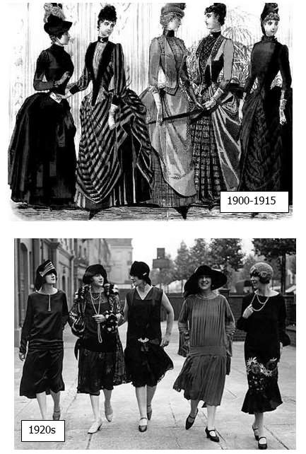

What do these fashion trends reveal about the changing role of women in the early
20th century?

A After the turmoil of World War I, women reverted to more traditional gender roles.

B The rise of religious fundamentalism led to a more traditional view of the roles of women.

C Changing fashions were a reflection of new, progressive roles for women.

D Gender roles were not impacted by changing cultural norms in the early part of the century.

10. This is a poster used during World War I.

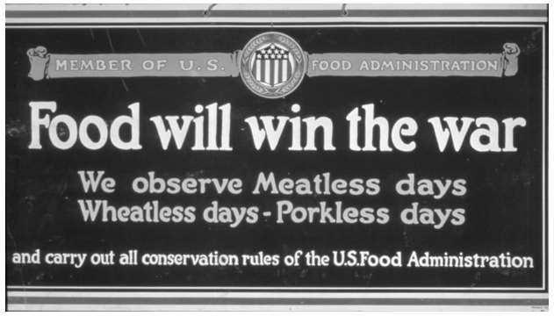
The message of this poster portrays what aspect of life on the home front? A government-mandated food conservation programs

B the use of propaganda to get people to comply with voluntary rationing efforts

C the unwillingness of citizens to make personal sacrifices for the war effort

D a push to teach children healthier eating habits

11. Historians argue that the success of the Populist Party was in its long-term influence rather than its electoral wins. What action is evidence of this idea?

A the passage of the 16th and 17th Amendments

B the strict regulation of the railroads by the federal government

C the success of William Jennings Bryan

D the adoption of silver as the basis of currency

12. This is an excerpt from the 24th Annual Report of the New York Association for the
Improvement of the Condition of the Poor.

What class of our citizens most strenuously resist the moral restrains of the community…. Who among our population give unrestricted and unregulated license to the ten thousand drinking places in the city, which are the chief receptacles of drunkenness, debauchery, villainy, and disease? It is the [residue] or dregs of four millions of European immigrants, including paupers, felons, and convicts that have landed at this port within the last twenty years.

Sentiments such as these contributed to what situation in the United States?

A the closing of Ellis Island and the end of open immigration

B the end of settlement houses and other organizations to help the poor

C a push to require all factory workers to attend church as part of their job duties

D an increase in nativism and discrimination toward immigrants

13. These are examples of some laws passed in the South in the early part of the 20th
century.

• All circuses, shows, and tent exhibitions, to which the attendance of more than one race is invited or expected…shall provide for the convenience of its patrons not less than two ticket offices with individual ticket sellers…not less than 25 feet part.
• It shall be unlawful for a Negro and white person to play together or in company with each other a game of pool or billiards.
• The officer in charge shall not bury, or allow to be buried, any colored persons upon ground set apart or used for the burial of white persons.
• All persons licensed to conduct a restaurant, shall serve either white people exclusively or colored people exclusively and shall not see to the two races within
the same room or serve the two races anywhere under the same license.

What impact did these laws have on the South?

A The well-defined social hierarchy attracted many immigrants to the South.

B The need for separate facilities created jobs that brought many northerners to the South.

C De jure segregation kept African Americans in an inferior social, political, and economic status.

D African American businesses thrived since they did not have to compete with white businesses.

14. This document was issued by many southern states after the end of Reconstruction.

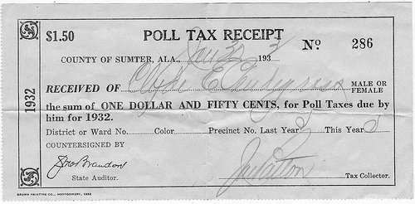
What was the main purpose of documents such as this one? A to collect revenue to pay for poll workers

B to stop corruption in state and local elections

C to prevent certain groups from being able to vote

D to ensure that the most qualified candidates ran for offices

15. This is an excerpt from a Supreme Court ruling in 1917.

When a nation is at war many things that might be said in time of peace are such a hindrance to its effort that their utterance will not be endured so long as men fight and no Court could regard them as protected by any constitutional right.

This ruling set what precedent in the United States?

A Freedom of speech is not absolute.

B Drafting men for the army is constitutional.

C Citizens can never criticize the government.

D Rights are the same in peacetime and wartime.

16. This photograph was taken in 1917.

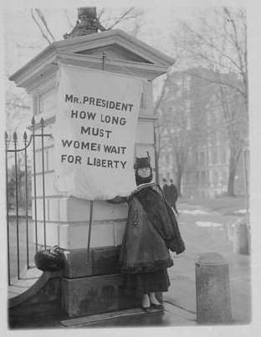

This photograph reflects what strategy of the women’s suffrage movement?

A a state-by-state campaign to win support

B petitioning the government for a constitutional amendment

C grassroots-level initiatives to change city and county laws

D the use of hunger strikes to gain media attention

17. What was the main focus of American imperialism in the late 19th and early 20th
centuries?

A avoiding military conflict with European nations

B acquiring new territories and increasing trade

C establishing American colonies in Africa

D maintaining a hands-off approach to international affairs

18. This is an excerpt from an article published in 2000 about modern-day sweatshops.

Contrary to what you have heard, sweatshops in third-world countries are a good deal for the people who work in them. Why? Because work, other than slave labor, is an exchange. A worker chooses a particular job because she thinks herself better off in that job than at her next-best alternative. Most of us would regard a low-paying job in Nicaragua or Honduras as a lousy job. But we’re not being asked to take those jobs. Those jobs are the best options those workers have, or else they would quit and work elsewhere…sweatshops are a normal step in economic development.

The author of this article would most likely support what idea from the Industrial
Age?

A labor strikes

B minimum wage laws

C Social Darwinism

D Progressivism

19. This is an excerpt from a speech given by President Theodore Roosevelt to Congress in
1904.

Chronic wrongdoing…may in America, as elsewhere, ultimately require intervention by some civilized nation…and in the western hemisphere the adherence to the Monroe Doctrine may force the United States, however reluctantly, in flagrant cases of such wrongdoing or impotence, to the exercise of an international police power.

The philosophy in this excerpt was used to justify what action taken by President
Roosevelt?

A negotiating a treaty to end the Russo-Japanese War

B sending the Great White Fleet on a goodwill tour around the world

C breaking up monopolies and trusts to improve the economy

D supporting the Panamanian Revolution in order to gain land to build a canal

20. This is an excerpt from the 17th Amendment.

The Senate of the United States shall be composed of two Senators from each state, elected by the people thereof, for six years; and each Senator shall have one vote.

Why did many progressive reformers advocate for this amendment?

A to increase the influence of state legislatures

B to prevent an individual state from having too much power

C to expand the democratic powers of the people

D to ensure only qualified people were elected to offices

21. This is an excerpt from a popular song in the early 1900s.

We have the land to raise the wheat And everything that’s good to eat And when we had no bonds or debts We were a jolly, happy set….

With abundant crops raised everywhere,
‘Tis a mystery, I do declare.
Why farmers all should fume and fret
And why we are so deep in debt….

What caused the problem addressed in this song?

A government ownership of the railroads

B overproduction of crops

C a lack of adequate irrigation

D high tariffs on imported crops

22. This cartoon was published in 1920 and is entitled Interrupting the Ceremony.

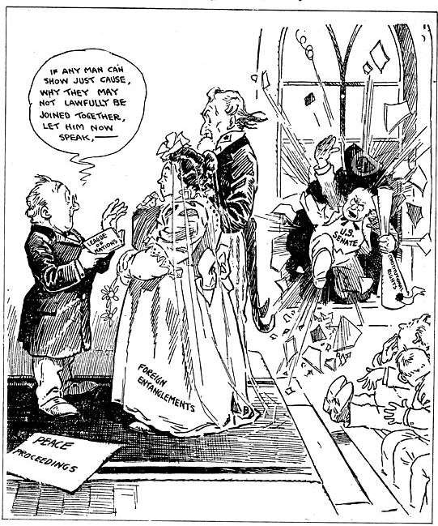

The author of this cartoon is satirizing what event?

A the annexation of the Philippines after the Spanish-American War B the Senate’s rejection of the Treaty of Versailles after World War I C the addition of the 19th Amendment to the U.S. Constitution
D the announcement of the Roosevelt Corollary to the Monroe Doctrine

23. This is an excerpt from a letter entitled Labor’s Bill of Grievances that was sent to the
president and Congressional leaders by Samuel Gompers.

The beneficent writ of injunction intended to protect property rights, as used in labor disputes, has been perverted so as to attack and destroy personal
freedom, and in a manner to hold that the employer has some property rights in the labor of workmen.

This excerpt is most likely referencing what event?

A the Pullman Strike

B the Haymarket Square Riot

C the passage of the Sherman Antitrust Act

D the election of Theodore Roosevelt

24. During the Industrial Age, what tactic was used by big business owners to maximize company profits?

A supporting the goals of labor unions

B advocating for low tariffs

C lobbying against laissez-faire government

D establishing monopolies and trusts

25. How did an increase in immigration between 1870 and 1916 impact the economy of the United States?

A It led to an ample labor force for new industry.

B It introduced new farming practices across the nation.

C It led to a general depression across economic sectors.

D It limited progress because employees had to be retrained frequently.

26. At the beginning of the 20th century, the settlement house movement was started to accomplish what goal?

A to encourage sharecroppers to move west and farm

B to convince the federal government to provide aid to the poorest citizens

C to provide assistance to poor immigrants in urban areas

D to establish public schools that included kindergarten for young children

27. This is an exchange that took place during a trial in 1925.

Judge Raulston: “Have you anything to say, Mr. Scopes, as to why the Court should not impose punishment on you?”

Defendant: “Your Honor, I feel that I have been convicted of violating an unjust statute. I will continue in the future, as I have in the past, to oppose the law in any way that I can. Any other action would be a violation of the idea of academic freedom.”

What issue was at the core of this trial?

A the clash between religious beliefs and emerging scientific views

B the use of government funds for private religious schools

C the debate over the constitutionality of segregation in public schools

D the need for more colleges to accept women and minorities as students

28. How did the federal government’s tariff policy impact the nation in the late 19th
century?

A Higher tariffs increased cotton exports.

B Higher tariffs encouraged more domestic manufacturing.

C Lower tariffs increased trade with foreign nations.

D Lower tariffs reduced inflation on consumer goods.

29. Why did President Wilson authorize the formation of the Creel Committee on Public
Information during World War I?

A to ensure that rationing laws were enforced

B to keep Americans informed about events going on in Europe

C to sway public opinion from supporting neutrality to supporting the war

D to increase regulation of the economy during wartime

30. This political cartoon was published during the Industrial Age.

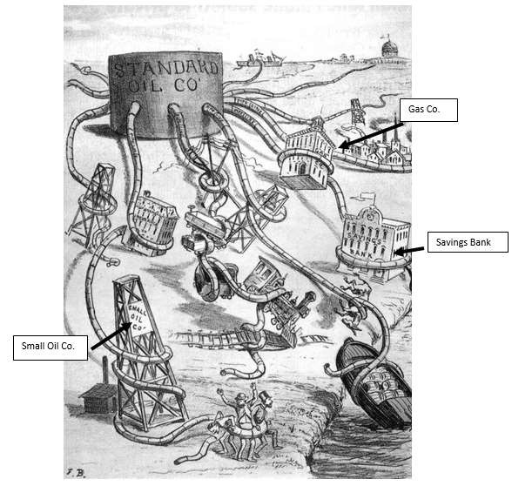

How did the federal government respond to the situation in this cartoon? A It took over companies that violated labor laws.

B It lowered tariffs to reduce the profits of large companies.

C It denied public resources to companies that violated federal laws.

D It increased regulations on monopolies and trusts.

31. Incidents such as the sinking of the Lusitania and the discovery of the Zimmermann
Note had what impact on the United States?

A They convinced the United States to withdraw all aid to the Allied Powers.

B They reinforced the United States’ commitment to remaining neutral. C They shifted public sentiment in favor of entering the war in Europe. D They caused President Wilson to lose his reelection bid.

32. This cartoon depicts President Teddy Roosevelt’s foreign policy philosophy.

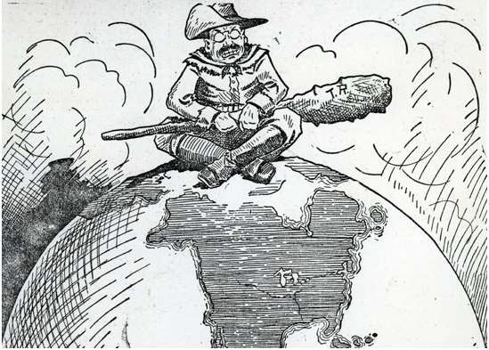

What action would President Teddy Roosevelt support to implement the policy depicted in this cartoon?

A building up a powerful military B ending tariffs on foreign goods C conserving natural resources
D promoting voting rights for women

33. This is an excerpt from an introduction to a biography of Andrew Carnegie.

Generous and naive while often grasping and ruthless, Andrew Carnegie personally embodied the contradictions that divided America in the Gilded Age. At a time when America struggled—often violently—to sort out the competing claims of democracy and individual gain, Carnegie championed both. He saw himself as a hero of working people, yet he crushed their unions. The richest man in the world, he railed against privilege. A generous philanthropist, he slashed the wages of the workers who made him rich.

This description of Carnegie is consistent with which set of conflicting ideas?

A Social Darwinism vs. laissez-faire

B Robber Baron vs. Captain of Industry

C socialism vs. communism

D trust vs. monopoly

34. This is an excerpt from an interview with Celeste Headlee in 2010.

My grandfather was one of the silent, determined millions who left the South because they wanted their full rights of citizenship. For him, it was the promise of a college education at an interracial school, Oberlin College in Ohio. For others, it was an assembly line job and $5 an hour in Detroit, or voting without fear, living where they chose, saying what they pleased without the danger of violent reprisal, and raising their children far from the swinging shadows of corpses hanging in southern trees. Turns out that the North and West weren’t the color-blind nirvanas that many blacks imagined, but Chicago and Cleveland were a far cry from Birmingham and Atlanta.

Based on this excerpt, which statement about Celeste Headlee’s grandfather is true?

A He was a World War I veteran.

B He was an immigrant who came through Ellis Island.

C He was a muckraker during the Progressive Era.

D He was part of the Great Migration.

35. During the Industrial Age, what factor made it difficult for labor unions to achieve their goals?

A The federal government tended to favor the interests of businesses over workers.

B Most factory workers were satisfied with their working conditions, and they refused to join labor unions.

C Collective bargaining practices made it possible for workers to negotiate directly with managers.

D State governments closely regulated labor unions, and a few even made strikes illegal.

